



PowerBoss Inc
14N845 US HWY 20 Pingree Grove, iL 60140
Phone: 800-323-9420 Fax 800-422-6933
www.powerboss.com

Product Bulletin

To: Valued PowerBoss Customers

From: PowerBoss Sales Support

Date: 10/1/2018

Subject: Atlas/ 6x Pump Cover Latch

Reason for Change

When closing the pump cover the previous bracket would occasionally not allow the latch to fully secure.

Improvement

A cut out has been made in the mounting bracket to allow full travel of the latching mechanism.

Applicable Models/Serial Numbers

Any of the listed units below with a seatbelt option.
PB620GAS PB620LP-DSB SW6XKGAS
PB620GAS-DSB PB620DSL SW6XKLPG
PB620LP PB620DSL-DSB SW6XKDSL



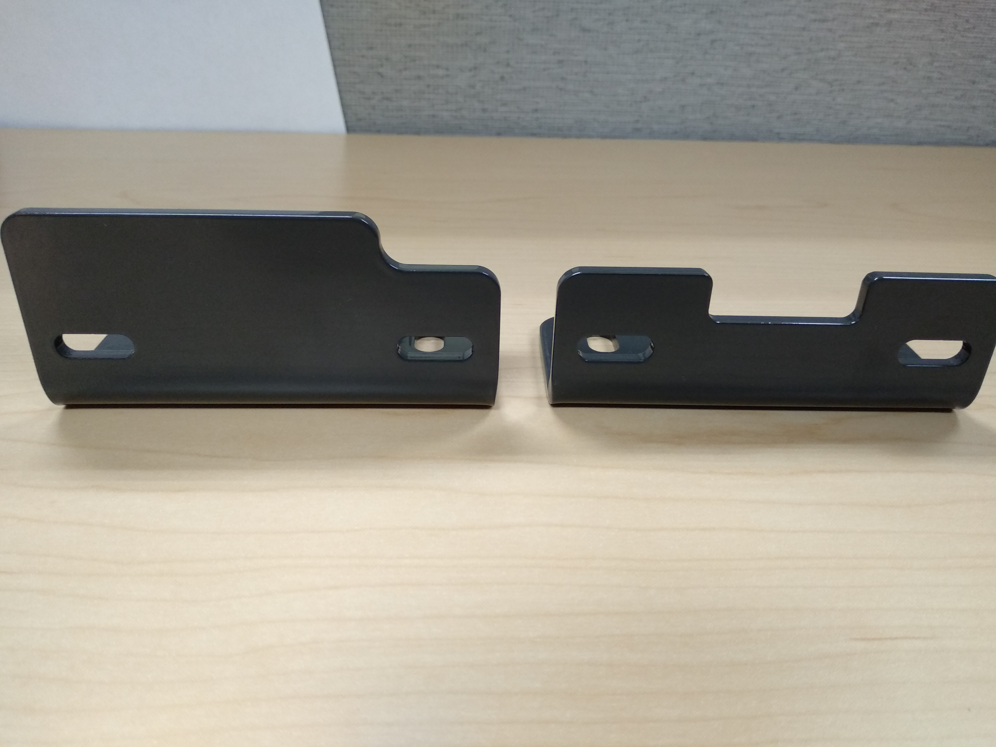
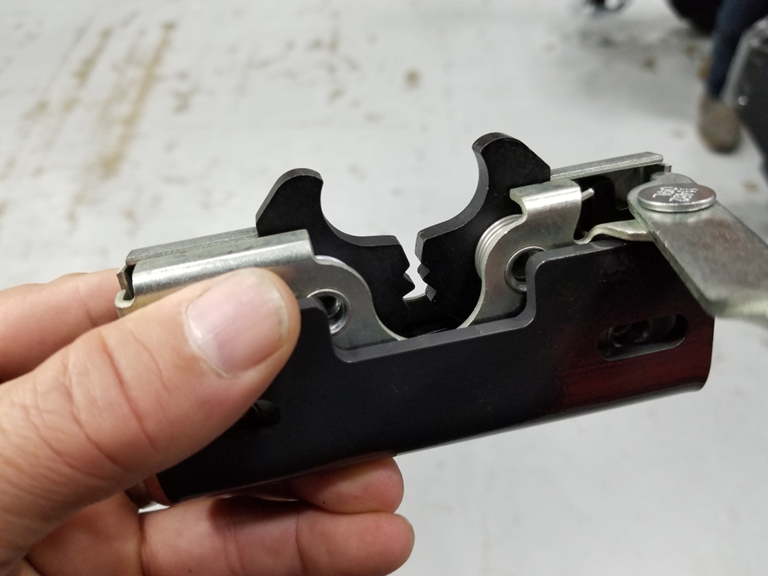

Before After Completed
For further assistance, questions, or comments contact PowerBoss Inc at 800-323-9420 (USA)

For further assistance, questions, or comments contact PowerBoss Inc at 800-323-9420 (USA)

